# Ecological responses to summer-fall pulse flows in the North Delta

Laura Twardochleb, Jesse Adams, Aaron Bever, Dave Bosworth, Ted Flynn, Michael MacWilliams, and Brittany Davis (author order TBD), and the FASTR Team

FASTR Team: Mallory Bedwell, Jared Frantzich, Rosemary Hartman, Jeff Jenkins, Nicole Kwan, Amanda Maguire, Sarah Perry, Catarina Pien, Traci Treleaven, Hailey Wright

Affiliations:

1. California Department of Water Resources
2. State Water Resources Control Board
3. Anchor QEA

# Introduction

Par. 1: Importance of food subsidies to supporting aquatic food webs- cite Nakano and Murakami, Power, Baxter, Polis, etc. – tie into supporting fish, esp. endangered species. Include delta/estuary food web examples as transition to next paragraph.

Par. 2: Importance of natural flow regime for food web productivity (cite Junk, Poff, Olden). History of management actions using pulse flows in other systems: e.g., Colorado River. Cite Kendy, Olden,

Par. 3: Background of food limitation in SFE contributing to declines of pelagic fish species. Cite references from report Intro. Management actions to increase food availability are being considered or implemented to benefit endangered species in the SFE, including using managed pulse flows to create food subsidies by transporting food from regions of high food concentration to regions of low concentration in pulse water.

Par. 4: Background of previous NDFS pulses and scientific evidence for increased productivity (reuse language from report Intro).

Par. 5: NDFS adaptive management.

-evaluate the effects of summer-fall flows in the bypass and CSC on ecological responses, the effect of water source

- to inform resource managers adaptively managing experiment flow pulses in the north delta, or elsewhere of findings

Research questions and hypotheses.

# Methods

## Study Area

The study area included the North Delta region of the upper San Francisco Estuary, ranging from Colusa Basin – Ridge Cut Slough to the Lower Sacramento River as the northernmost and southernmost locations, respectively. Two key regions evaluated within the study area were the Yolo Bypass and Cache Slough Complex, as together, they represent the largest remaining area of floodplain and freshwater tidal slough habitat (Frantzich et al. 2018) that may be critical for ESA-listed species and are the focus for a number of conservation actions. The Knights Landing Ridge Cut is a 10 km channel that connects the Colusa Basin Drain to the Yolo Bypass (i.e. Colusa Basin-Ridge Cut area) allowing water from Glenn-Colusa (e.g. agricultural return water, Sacramento River water, and other water inputs to pass or drain through the bypass. The Yolo Bypass is a 24,000-hectare and 60 km long floodplain and tidal slough, that is partially leveed and serves as the primary flood control system for Sacramento, CA. During wetter conditions the bypass typically has positive flow downstream to CSC and Lower Sacramento River from overtopping of the Fremont weir with Sacramento River water and/or additional inputs from western tributaries. During drier conditions, particularly in summer-fall, the wetted area of the Yolo Bypass is reduced to a narrow perennial canal, called the Toe Drain. The Cache Slough Complex (CSC) is a region of tidal wetlands and dead-end sloughs that is connected to the base of the Yolo Bypass Toe Drain and is one of the remaining habitats characteristic of the historic estuary. The CSC includes complex habitat such as small sloughs, channels, and open water which can influence foodweb production and is likely why it has served as an important habitat for native fishes historically (Sommer and Mejia, 2013; Young et al. 2021). While the summer-fall season leads to drier and low-flow conditions in the North Delta, the seasonal effect on flows is exacerbated with higher water diversion rates for agriculture, recreation and water management. Summer-fall water use in many cases exceeds the supply of water inputs into the bypass and changes hydrology by reversing outflow to low or net negative (i.e. net flow is upstream after accounting for tidal effects) (Frantzich et al. 2018). We also used Sherwood Harbor on the mainstem Sacramento River as a reference to contrast to bypass and CSC flows.

## Augmented Flows

Description of managed and unmanaged flow pulses; how they are generated with existing infrastructure, source water, timing.

Summer-fall flows in the Yolo Bypass can be altered by a number of source inputs and/or combination of inputs as well as exports, some of which are unmanaged and others managed. A description of flow pulses from 2011 to 2019 are summarized in Table 1. Unmanaged, small to moderate flow pulses occur in the upper Yolo Bypass annually between August and October dependent on local agriculture and wildlife area activities (Anchor QEA 2023); however, inputs are typically not enough to reverse net negative flow out of CSC (2013, 2015, 2017). Unmanaged, larger than normal flows or pulses in summer-fall have resulted from antecedent wet winter and spring conditions correlated with overtopping of the Fremont Weir and Sacramento River input into the bypass, tributary inputs, increased precipitation, stormwater drainage (2011), agriculture drainage and operational needs (2012; Franztich et al. 2018), or a combination of inputs (2015??), all of which are mostly not coordinated. Managed flow pulses, however, have been highly coordinated through the planned use of existing water conveyance infrastructure (Frantzich et al. 2021) with the intent to reverse net negative flow in the bypass for ecological benefits (e.g. plankton). For example, experimental flow pulses in 2016, 2018, and 2019 conducted by the Department of Water Resources in collaboration with reclamation and irrigation districts, landowners, and agency partners redirected Sacramento River water (2016) or agriculture return water (mostly from rice crop in 2018 and 2019) into the Yolo Bypass through reoperation of the Knights Landing Outfall Gates and other water-control structures. Details of managed flow pulse operations and infrastructure are described in Frantzich et al. (2021) and DWR 2023. In brief, 2016, Sacramento River water was pumped into the Colusa Basin Drain in summer (July), that was immediately passed through the bypass. The use of Sacramento River water to augment flow in the bypass were constrained to summer due to agriculture timing requirements and consideration of salmonids. In contrast, 2018 and 2019 flow pulses were sourced from agricultural drainage in late summer-fall (August to -September) that tried to recreate flows observed in 2012. Agricultural drainage water is originally sourced from Sacramento River water used to irrigate fields; however, the water source has changed as it aged on fields undergoing chemical and physical processes and pesticide applications.

Table 0‑1. Flow pulse magnitude and duration measured at Lisbon Weir in the Yolo Bypass (Yolo) and modeled between the Cache Slough Complex (CSC) ‑. WY indicates water year type including wet (W), below normal (BN), dry (D), and critically dry (C). Flow pulse duration was measured or modeled as the number of days with positive flow at LIS in Yolo Bypass, or the number of days with net positive flow out of CSC. Flow pulse magnitude is measured in maximum daily average cubic feet per second (cfs) and thousand-acre feet (TAF). In the absence of flow pulses, net flow is negative (upstream) through the Yolo Bypass during this time. Asterisks besides year indicate pulses that were the result of planned, managed, and coordinated pulses.

|  |  |  |  |  |  |  |  |
| --- | --- | --- | --- | --- | --- | --- | --- |
| **Year** | **WY Type** | **Duration** | | **Magnitude (Yolo)** | | | **Date Range of pulse (Yolo, estimated)** |
| **Days Net Positive Flow (Yolo, measured)** | **7-Day Ave Net Positive Flow (CSC, modeled)** | **Max Daily Ave Net Flow (cfs, measured)** | **Total Net Positive Flow Volume (TAF, measured)** | **Volume Relative to No Flow Pulse (TAF, modeled)** |
| 2011 | W | 63 | 16 | 412 | 22.4 | 16.6 | Aug 23 – Oct 24 |
| 2012* | BN | 38 | 26 | 723 | 27.2 | 31.4 | Aug 26 – Oct 2 |
| 2013 | D | 42 | - | 283 | 11.4 | 18.5 | Aug 22 – Oct 2 |
| 2014 | C | 15 | - | 239 | 2.5 | 2.6 | Sep 9 –  Sep 23 |
| 2015 | C | 42 | - | 383 | 17.9 | 28.4 | Aug 21 – Oct 1 |
| 2016* | BN | 19 | 5 | 546 | 12.8 | 15.8 | Jul 14 –  Aug 1 |
| 2017 | W | 12 | 2 | 125 | 1.0 | 2.6 | Aug 29 – Sep 18 |
| 2018* | BN | 30 | 14 | 548 | 19.8 | 23.6 | Aug 28 – Sep 26 |
| 2019* | W | 26 | 24 | 750 | 31.6 | 32.4 | Aug 26 – Sep 21 |

## Hydrodynamic Modeling

Hydrodynamic modeling was conducted to evaluate the fate of water originating in the CSC and water originating from the flow pulses by tracking the water through the CSC and farther downstream. A version of the 3-D UnTRIM Bay-Delta model (MacWilliams et al. 2015) with high resolution in the CSC (Frantzich et al. 2021) was used to simulate water flow and tracer transport throughout the San Francisco Bay and Sacramento-San Joaquin Delta. The higher-resolution area extends from the Toe Drain at Lisbon Weir through the southern portion of Liberty Island and resolves bathymetric features (e.g., levee breaches, deep channels, stair-step channels) needed to predict the routing of water through this complex area. The UnTRIM Bay-Delta model has been previously validated and shown to accurately predict water level, water flow, and salinity under a wide range of conditions (MacWilliams et al. 2015).

Hydrodynamic modeling was conducted for flow pulses in 6 years with varying flow pulse magnitudes and durations: 2011, 2012, 2016, 2017, 2018, and 2019 (Fig. 2-1). Model simulations included at least 1.5 months of spinup and then simulated 3 months around the flow pulse in each year. A conservative tracer, similar to a dye, was used to track the flow pulse water and determine the percentage of the water that originated from the flow pulse at any given location and any given time. Only incoming water past Lisbon Weir during the flow pulse was tagged with the tracer.

The total amount of flow pulse water through time at a given location was used as a cumulative metric to compare the amount of flow pulse water at a given location over 60 days beginning at the start of the flow pulse. The total amount of flow pulse water was calculated by multiplying the percent of flow pulse water at a location by the amount of time at that percent. This was termed the total flow pulse water. The total flow pulse water conveniently incorporates both the amount of flow pulse water at a given location and the duration into a single metric. As an example, if 10% of the water at a given location originated from a flow pulse for a period of 10 days, the total flow pulse water is 100 percent days. Alternatively, 20% flow pulse water for 5 days also equates to 100 percent days. Thus, similar total flow pulse water percent days can be achieved with lower percentages over a longer time or higher percentages over a shorter time. The total flow pulse water is similar to other cumulative metrics used to summarize conditions over time, such as temperature (*****) and hypoxia (Bever et al. 2013).

Fig. 2-1 from report- summary of pulse flows measured at Lisbon Weir

Graph of flow at Lisbon Weir in cubic feet per second versus days since the start of the flow pulse for 2011-2019.



Figure . Daily-averaged observed flow past Lisbon Weir for 2011 through 2019 (Top) and modeled water flow between Liberty Island and Cache Slough. Dashed lines indicate years not simulated in this analysis. Negative flow indicates northward upstream flow past Lisbon Weir and flow into Liberty Island.

## Food Web Monitoring

## Data Analysis

Possible new analyses include: GAMs to account for effects of seasonality on responses. Include a continuous predictor like total volume of water moved during flow pulse?

**GAMS analysis plan:**

~~First pass: Dave will test GAMs with continuous chla using region and flow pulse period interaction and random effect of station and using a smoother for day of year to account for seasonality. Will complete by end of January and share with the team. Jesse and Ted will then decide whether to run a similar model for phytoplankton and zooplankton data.~~

~~Second pass: Jesse and Ted will run GAMs on zoop CPUE and phyto biovolume using the same procedure that Dave used for continuous chla.~~

~~E.g., Zoop cpue ~ Year * Flow pulse period + Year * Region + Flow pulse period * Region + Random (Station) + smooth (DOY).~~

~~Jesse will also run the zooplankton NMDS code to see if everything is working.~~

~~Next steps:~~

1. ~~Dave will add continuous predictors to his third-order autoregressive model. We decided to use daily average flow at LIS as a continuous predictor of flow (or use modeled flow data from Michael and Aaron). We also decided to run a model with station as a predictor replacing region, and to run a similar model with dissolved oxygen data.~~

~~E.g., Chla ~ Year * Daily avg. flow + Year * Station + Daily avg. flow * Station + smooth (DOY).~~

1. ~~Dave will apply similar model to DO data, possibly also including temperature as a predictor to disentangle effects of temperature from flow pulse.~~
2. ~~Laura will run similar linear models including flow as a predictor (LIS flow or modeled flow data) on phyto biovolume and zoop CPUE data.~~
3. ~~Jesse will run zooplankton multivariate analyses by modifying Ted’s phytoplankton code.~~
4. ~~Michael and Aaron will add the Lib island and Rio Vista percent flow pulse water figure.~~
5. ~~Consider a structural equation model or other path analysis to tie the pieces together as a final analysis.~~

7. Dave run additional model steps on chl-a GAMs (Exploring responses by site (representative of upstream, STTD, and downstream; Potentially remove smoother for day of year); add in flow pulse period as predictor to interact with flow

8. Add temperature as proxy for season

9. Model selection on GAMs/LMs

**Final data analysis plan:**

### Water Quality

Chl-a: GAM with smoother for year and autocorrelation (present results of model selection for models with/without flow and other variables)

* Consider adding turbidity, temperature, EC (may be correlated with flow) as predictor and flow pulse period
* Exploring responses by site (representative of upstream, STTD, and downstream)
* Potentially remove smoother for day of year
* ~~Consider using daily avg. percent flow pulse water~~

Figures in main text: multipanel figure with continuous predictors, and chl-a responses at the three representative sites, and a panel to represent overall chl-a model (consider panel of discrete predictors for representative sites)

Supplement: figures/analyses of physical wq from report (secchi depth, EC, continuous turbidity, temperature, DO, pH), nutrients (ammonia, nitrate, dissolved orthophosphate)- also consider referring to the report

### Phytoplankton

Analyses:

* ANOVA (phyto biovolume~flow pulse period*year+flow pulse period*region+year*region + 1/station)
* perMANOVA (community composition~ flow pulse period*year+flow pulse period*region+year*region + 1/station)
* ANOSIM (for each year: community composition ~ region + flow pulse period)
* lm (phyto biovolume~flow + station) (in supplement)
* emmeans results from ANOVA (in supplement)
* results from individual taxonomic groups

Figures:

* Biovolume by flow pulse period, region, and year
* Community composition bar charts by year, region, and pulse period
* NMDS by flow pulse period, region, and year
* supplement (year by station composition figures, LCFA index)

### Zooplankton

Analyses:

* ANOVA (zoop CPUE~flow pulse period*year+flow pulse period*region+year*region + 1/station)
* perMANOVA (community composition~ flow pulse period*year+flow pulse period*region+year*region+ 1/station)
* ANOSIM (for each year: community composition ~ region + flow pulse period)
* lm (zoop CPUE~flow + station) (in supplement)
* emmeans results from ANOVA (in supplement)
* ANOVAs from individual taxonomic groups

Figures:

* CPUE by flow pulse period, region, and year
* Community composition bar charts by year, region, and pulse period
* NMDS by flow pulse period, region, and year
* supplement (year by station composition figures)

### Tying it all together? SEM

# Results

### Hydrodynamics

Previous studies showed flow pulses in the Toe Drain can reverse the net flow of water between Liberty Island and Cache Slough, such that the net flow is out of the CSC (Frantzich et al. 2021). The magnitude and duration of the flow pulses also influences the percent of water at a given location that originated from the flow pulse. At the base of Liberty Island and the Sacramento River at Rio Vista Bridge, the percent flow pulse water was the highest during 2012 and 2019 (Fig. 2), the years with the highest peak flow (Fig. 1). Percent flow pulse water was the lowest during 2017, which had the smallest flow pulse. By 60 days after the start of the flow pulses, the percent flow pulse water was the highest in 2011 because of the long duration of the 2011 flow pulse.

At the base of Liberty Island, total flow pulse water was the greatest during 2019 because the percent flow pulse water increased faster following the start of the flow pulse than the other years and remained elevated (Fig. 2). The next year with the most total flow pulse water was 2012, followed by 2018, 2011, 2016, and finally 2017. At the Sacramento River at Rio Vista Bridge, total flow pulse water was the greatest during 2012, followed by 2019, 2018, 2011, 2016, and finally 2017. The switch in year with greatest total flow pulse water between the two locations indicates that conditions outside the CSC influence the amount of flow pulse water present downstream of the CSC. By the total flow pulse water metric, the flow pulses in 2019 and 2012 resulted in the most flow pulse water at these locations, relatively little flow pulse water in 2016, and very little flow pulse water was transported to these locations in 2017.

Figure 2-4 or 2-5 from report- flow pulse water moving past Cache Slough Complex or Liberty Island:



Figure . Percent flow pulse water at the base of Liberty Island and Sacramento River at Rio Vista Bridge for each of the simulated years. Vertical dashed lines indicate the end of the flow pulse in each year.

Include Figure like 2-5 but with percent days instead of water age. Four panels: on the left of Liberty Island and Rio Vista on right.

### Chlorophyll

Figures 3-4, 3-5, and 3-6, reworked to emphasize managed vs. unmanaged pulses and demonstrate effects of seasonality vs. flow pulses (or include continuous predictors and show GAMs results)

Figure . Daily average chlorophyll fluorescence values in the upstream region, downstream region, and middle Sacramento River in the years with high flow, high magnitude, and short duration flow pulses (2012, 2016, 2018, and 2019). The light grey shaded box represents the flow pulse period, and each plot for the upstream region has a different y-axis scale.

Figure . Daily average chlorophyll fluorescence values in the upstream region, downstream region, and middle Sacramento River in the years with high flow, low magnitude, and long duration flow pulses (2011 and 2015). The light grey shaded box represents the flow pulse period, and the plots for each region have different y-axis scales.

Figure . Daily average chlorophyll fluorescence values in the upstream region, downstream region, and middle Sacramento River in the years with low-flow pulses (2013, 2014, and 2017). The light grey shaded box represents the flow pulse period, and each plot for the upstream region has a different y-axis scale.

### Phytoplankton

Figure 4-2: Total biovolume by flow pulse period, region, and year

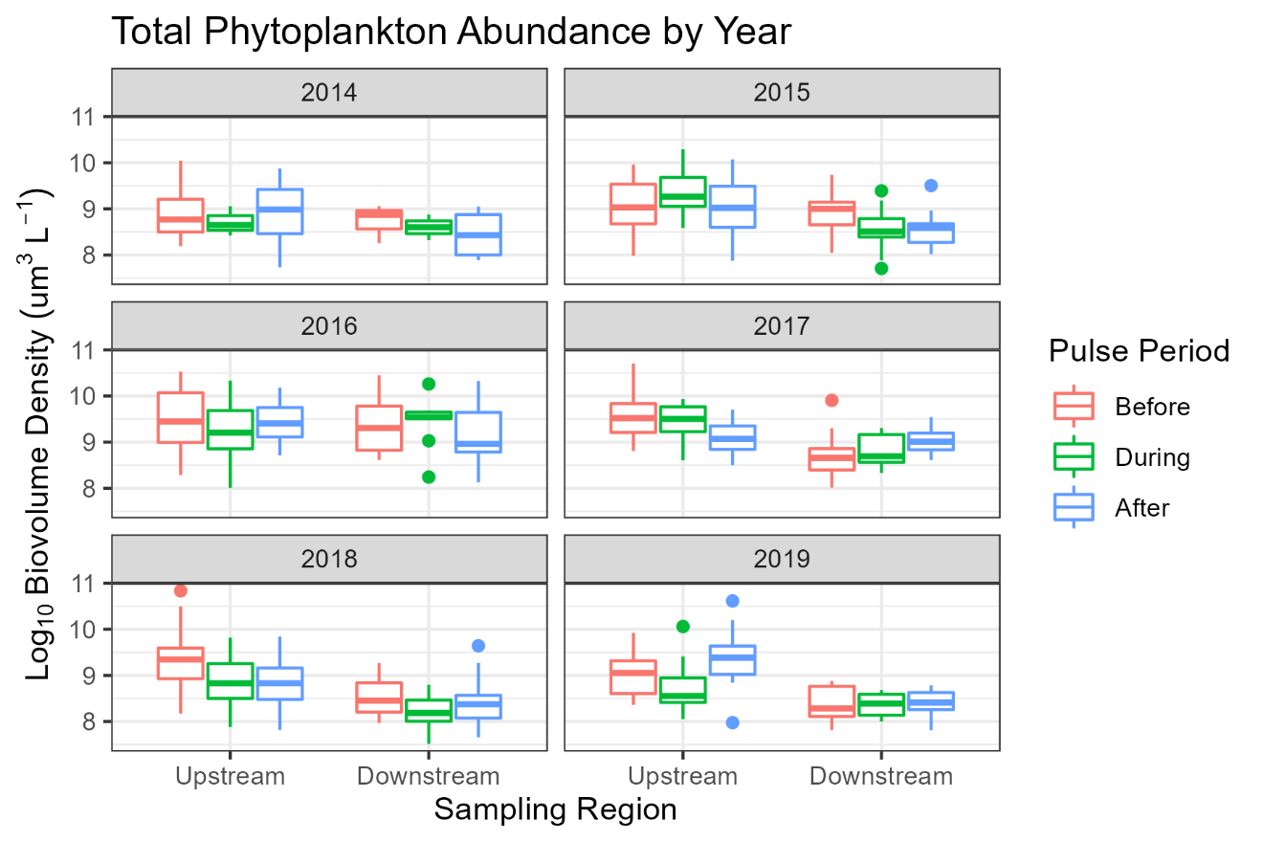

Figure . Box plot showing quartiles of total phytoplankton biovolume in the Upstream and Downstream regions of the study area before, during, and after the flow pulses.

Figure 4-6: Average biovolume by functional groups before, during, and after flow pulses by region and year

Figure . Average biovolume of phytoplankton functional groups detected before, during, and after flow pulses in the upstream and downstream regions for each year of the study.

Figure . Figure 4 20. Non-metric multidimensional scaling plot of phytoplankton samples colored by flow pulse period (before, during, after), faceted by year.

Table . ANOSIM Results comparing upstream and downstream phytoplankton community composition for each year before, during, and after flow pulses.

|  |  |  |  |  |  |  |  |
| --- | --- | --- | --- | --- | --- | --- | --- |
|  |  | **Before** | | **During** | | **After** | |
| **Year** | **Pulse** | **R** | **p-value** | **R** | **p-value** | **R** | **p-value** |
| 2014 | Low | 0.266 | 0.129 | - | - | 0.320 | 0.017 |
| 2015 | High | -0.028 | 0.650 | 0.544 | 0.0001 | 0.325 | 0.0001 |
| 2016 | High | 0.146 | 0.059 | 0.395 | 0.0002 | 0.418 | 0.0001 |
| 2017 | Low | 0.365 | 0.0001 | 0.442 | 0.0001 | 0.148 | 0.030 |
| 2018 | High | 0.217 | 0.0004 | 0.246 | 0.0001 | 0.356 | 0.0001 |
| 2019 | High | 0.149 | 0.062 | 0.184 | 0.026 | 0.503 | 0.0002 |

Figure . Non-metric multidimensional scaling plot of phytoplankton communities from all years (2014—2019) before, during, and after flow pulse, colored by region (upstream, downstream).

### Zooplankton

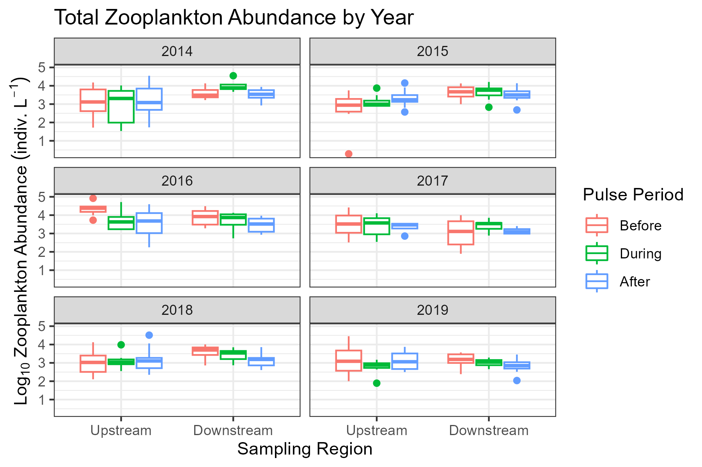

Figure . Box plot showing quartiles of total zooplankton CPUE in the Upstream and Downstream regions of the study area before, during, and after the flow pulses.

Table 3. ANOVA test of effects and interactions of region, year, and sample period, with station as a random effect, on total zooplankton (nauplii excluded) CPUE

|  |  |  |  |  |
| --- | --- | --- | --- | --- |
| model4.1 <- lmer(log(cpue) ~ Regions2*Year+Year*SamplePeriod+SamplePeriod*Regions2+(1|StationCode),data = zoopNDFA7,REML = TRUE) | | | | |
|  | F | Df | Df.res | Pr(>F) |
| (Intercept) | 411.5105456 | 1 | 52.14769 | 0 |
| Regions2 | 7.309153 | 1 | 29.79917 | 0.0112207 |
| Year | 5.4255161 | 5 | 339.36282 | 0.0000812 |
| SamplePeriod | 0.5676934 | 2 | 339.02843 | 0.5673693 |
| Regions2:Year | 6.7527461 | 5 | 339.46836 | 0.0000051 |
| Year:SamplePeriod | 1.8650837 | 10 | 339.39407 | 0.0490519 |
| Regions2:SamplePeriod | 2.7466134 | 2 | 339.17197 | 0.0655719 |

Table 4. Estimated marginal means for the total zooplankton CPUE linear mixed effects model with Sidak adjusted pairwise comparisons for Region by Year

|  |  |  |  |  |  |  |
| --- | --- | --- | --- | --- | --- | --- |
| lmer_emm <- emmeans(model4.1, specs = pairwise ~Regions2|Year,adjust="sidak) | | | | | | |
| contrast | Year | estimate | SE | df | t.ratio | p.value |
| Downstream - Upstream | 2014 | 1.2222804 | 0.4469975 | 22.9314 | 2.7344233 | 0.0118356 |
| Downstream - Upstream | 2015 | 1.2567753 | 0.4297879 | 19.66923 | 2.9241755 | 0.0084885 |
| Downstream - Upstream | 2016 | -0.1621467 | 0.447717 | 22.99834 | -0.3621635 | 0.7205365 |
| Downstream - Upstream | 2017 | -0.6808524 | 0.4527031 | 24.04497 | -1.5039712 | 0.1456114 |
| Downstream - Upstream | 2018 | 0.9044751 | 0.400264 | 14.78186 | 2.2596962 | 0.0393902 |
| Downstream - Upstream | 2019 | -0.0552653 | 0.446887 | 22.91253 | -0.1236672 | 0.9026572 |

Table 5. Estimated marginal means for the total zooplankton CPUE linear mixed effects model with Sidak adjusted pairwise comparisons for Flow pulse period by Year

|  |  |  |  |  |  |  |
| --- | --- | --- | --- | --- | --- | --- |
| lmer_emm2 <- emmeans(model4.1, specs = pairwise ~SamplePeriod|Year,adjust="sidak")#post hoc test on sampleperiod and year | | | | | | |
| contrast | Year | estimate | SE | df | t.ratio | p.value |
| Before - During | 2014 | -0.1441128 | 0.4818763 | 339.0231 | -0.299066 | 0.9870342 |
| Before - After | 2014 | -0.0040036 | 0.3542916 | 339.0098 | -0.0113004 | 0.9999993 |
| During - After | 2014 | 0.1401092 | 0.4562412 | 339.0102 | 0.3070946 | 0.9859955 |
| Before - During | 2015 | -0.5132731 | 0.3704721 | 339.1442 | -1.3854568 | 0.4216226 |
| Before - After | 2015 | -0.6313447 | 0.3717695 | 339.369 | -1.6982151 | 0.247382 |
| During - After | 2015 | -0.1180716 | 0.3556705 | 339.0774 | -0.3319689 | 0.9824479 |
| Before - During | 2016 | 0.8531637 | 0.5027936 | 339.3611 | 1.6968468 | 0.2480241 |
| Before - After | 2016 | 1.3449034 | 0.374005 | 339.8485 | 3.59595 | 0.0011129 |
| During - After | 2016 | 0.4917397 | 0.449959 | 339.3343 | 1.0928545 | 0.6192891 |
| Before - During | 2017 | -0.3332079 | 0.3623735 | 339.0028 | -0.9195151 | 0.7359838 |
| Before - After | 2017 | 0.2711813 | 0.4851563 | 341.0296 | 0.5589565 | 0.9240756 |
| During - After | 2017 | 0.6043892 | 0.511443 | 340.8222 | 1.1817332 | 0.5577852 |
| Before - During | 2018 | 0.0988192 | 0.3191745 | 339.0288 | 0.3096086 | 0.9856597 |
| Before - After | 2018 | 0.5019024 | 0.2982733 | 339.4056 | 1.6826929 | 0.2547311 |
| During - After | 2018 | 0.4030832 | 0.3237632 | 339.1876 | 1.244994 | 0.5144001 |
| Before - During | 2019 | 0.5958305 | 0.3968813 | 339.0027 | 1.5012812 | 0.3510187 |
| Before - After | 2019 | 0.4395092 | 0.3968348 | 339.0029 | 1.1075369 | 0.6091369 |
| During - After | 2019 | -0.1563212 | 0.3968915 | 339.0033 | -0.3938639 | 0.9713275 |

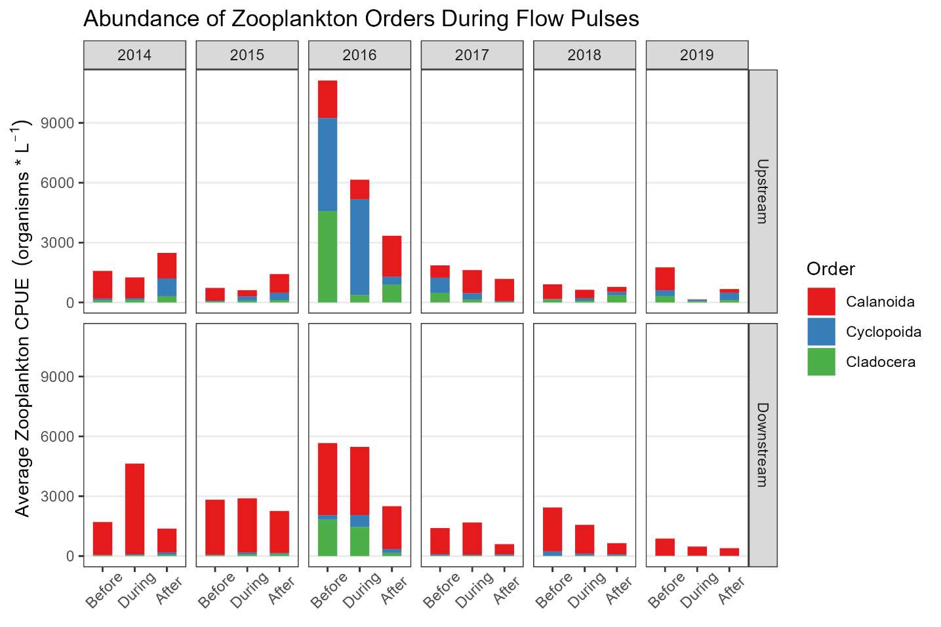

Figure . Average zooplankton CPUE for dominant orders before, during, and after flow pulses in the upstream and downstream regions for each year of the study.

Table . ANOVA test of effects and interactions of region, year, and sample period, with station as a random effect, on cyclopoid copepod (nauplii excluded) CPUE

|  |  |  |  |  |  |
| --- | --- | --- | --- | --- | --- |
| model4.1_cyclo <- lmer(log(cpue) ~ Regions2*Year+Year*SamplePeriod+SamplePeriod*Regions2+(1|StationCode), data = zoopNDFA5_cyclopoid,REML = TRUE) | | | | | |
|  | F | Df | Df.res | Pr(>F) |  |
| (Intercept) | 34.9476 | 1 | 75.05 | 9.33E-08 | *** |
| Regions2 | 5.6533 | 1 | 40.76 | 0.022197 | * |
| Year | 5.5955 | 5 | 316.69 | 5.87E-05 | *** |
| SamplePeriod | 3.0185 | 2 | 316.18 | 0.050283 | . |
| Regions2:Year | 3.2838 | 5 | 316.91 | 0.006611 | ** |
| Year:SamplePeriod | 2.586 | 10 | 316.65 | 0.005034 | ** |
| Regions2:SamplePeriod | 0.2313 | 2 | 316.81 | 0.793638 |  |
| Signif. codes: 0 ‘***’ 0.001 ‘**’ 0.01 ‘*’ 0.05 ‘.’ 0.1 ‘ ’ 1 | | | | | |

Table . Estimated marginal means for the cyclopoid copepod linear mixed effects model with Sidak adjusted pairwise comparisons for Region by Year

|  |  |  |  |  |  |  |
| --- | --- | --- | --- | --- | --- | --- |
| lmer_emm_cyclo <- emmeans(model4.1_cyclo, specs = pairwise ~Regions2|Year,adjust="sidak") | | | | | | |
| contrast | Year | estimate | SE | df | t.ratio | p.value |
| Downstream - Upstream | 2014 | -1.44741 | 0.511587 | 29.38242 | -2.82926 | 0.008325 |
| Downstream - Upstream | 2015 | -1.26728 | 0.510334 | 29.04422 | -2.48324 | 0.019038 |
| Downstream - Upstream | 2016 | -1.89597 | 0.517585 | 30.60903 | -3.66311 | 0.000935 |
| Downstream - Upstream | 2017 | -2.20181 | 0.506978 | 28.36113 | -4.34301 | 0.000163 |
| Downstream - Upstream | 2018 | -0.7493 | 0.44079 | 16.35611 | -1.6999 | 0.108085 |
| Downstream - Upstream | 2019 | -2.41415 | 0.497002 | 26.35993 | -4.85743 | 4.73E-05 |

Table . Estimated marginal means for the cyclopoid copepod linear mixed effects model with Sidak adjusted pairwise comparisons for flowpulse period by Year

|  |  |  |  |  |  |  |
| --- | --- | --- | --- | --- | --- | --- |
| lmer_emm_cyclo_sp <- emmeans(model4.1_cyclo, specs = pairwise ~SamplePeriod|Year,adjust="sidak") | | | | | | |
| contrast | Year | estimate | SE | df | t.ratio | p.value |
| Before - During | 2014 | -0.72277 | 0.607335 | 316.0672 | -1.19007 | 0.55215 |
| Before - After | 2014 | -1.32183 | 0.445453 | 316.6395 | -2.96738 | 0.009666 |
| During - After | 2014 | -0.59906 | 0.55743 | 316.3337 | -1.07468 | 0.631921 |
| Before - During | 2015 | -1.94055 | 0.479837 | 316.6736 | -4.0442 | 0.000198 |
| Before - After | 2015 | -1.73281 | 0.495828 | 316.5461 | -3.49478 | 0.001626 |
| During - After | 2015 | 0.207743 | 0.448115 | 316.3149 | 0.463594 | 0.954599 |
| Before - During | 2016 | -0.42382 | 0.637461 | 316.6124 | -0.66485 | 0.879907 |
| Before - After | 2016 | 0.943209 | 0.475887 | 317.1876 | 1.982001 | 0.138128 |
| During - After | 2016 | 1.367025 | 0.556607 | 316.6659 | 2.455995 | 0.043124 |
| Before - During | 2017 | -0.46678 | 0.429796 | 316.072 | -1.08605 | 0.62408 |
| Before - After | 2017 | -0.27691 | 0.566453 | 318.8703 | -0.48885 | 0.947385 |
| During - After | 2017 | 0.189866 | 0.603714 | 319.0883 | 0.314497 | 0.984995 |
| Before - During | 2018 | -1.01115 | 0.374543 | 316.0981 | -2.69968 | 0.021783 |
| Before - After | 2018 | -0.73091 | 0.350622 | 316.7698 | -2.08462 | 0.109457 |
| During - After | 2018 | 0.280232 | 0.377443 | 316.2684 | 0.742449 | 0.841103 |
| Before - During | 2019 | -0.34437 | 0.462658 | 316.003 | -0.74434 | 0.840097 |
| Before - After | 2019 | -0.78888 | 0.462611 | 316.0047 | -1.70528 | 0.244254 |
| During - After | 2019 | -0.44451 | 0.462667 | 316.0047 | -0.96075 | 0.709107 |

Table . ANOVA test of effects and interactions of region, year, and sample period, with station as a random effect, on calanoid copepod (nauplii excluded) CPUE

|  |  |  |  |  |  |
| --- | --- | --- | --- | --- | --- |
| model4.1_cal <- lmer(log(cpue) ~ Regions2*Year+Year*SamplePeriod+SamplePeriod*Regions2+(1|StationCode),data = zoopNDFA5_calanoid,REML = TRUE) | | | | | |
|  | F | Df | Df.res | Pr(>F) |  |
| (Intercept) | 94.5252 | 1 | 10.55 | 1.36E-06 | *** |
| Regions2 | 9.7043 | 1 | 9.05 | 0.012333 | * |
| Year | 2.9376 | 5 | 329.04 | 0.013072 | * |
| SamplePeriod | 3.265 | 2 | 329.01 | 0.039437 | * |
| Regions2:Year | 6.6181 | 5 | 329.06 | 6.90E-06 | *** |
| Year:SamplePeriod | 1.6382 | 10 | 329.05 | 0.09458 | . |
| Regions2:SamplePeriod | 6.2704 | 2 | 329.06 | 0.002125 | ** |
| Signif. codes: 0 ‘***’ 0.001 ‘**’ 0.01 ‘*’ 0.05 ‘.’ 0.1 ‘ ’ 1 | | | | | |

Table . Estimated marginal means for the calanoid copepod linear mixed effects model with Sidak adjusted pairwise comparisons for Region by Year

|  |  |  |  |  |  |  |
| --- | --- | --- | --- | --- | --- | --- |
| lmer_emm_cal_ry <- emmeans(model4.1_cal, specs = pairwise ~Regions2|Year,adjust="sidak") | | | | | | |
| contrast | Year | estimate | SE | df | t.ratio | p.value |
| Downstream - Upstream | 2014 | 3.653882 | 1.099376 | 8.528964 | 3.323598 | 0.009579 |
| Downstream - Upstream | 2015 | 3.664658 | 1.090429 | 8.25516 | 3.360748 | 0.00948 |
| Downstream - Upstream | 2016 | 2.332834 | 1.105204 | 8.709939 | 2.110773 | 0.065001 |
| Downstream - Upstream | 2017 | 1.227424 | 1.102522 | 8.626439 | 1.113288 | 0.295643 |
| Downstream - Upstream | 2018 | 3.16651 | 1.076385 | 7.837838 | 2.9418 | 0.019083 |
| Downstream - Upstream | 2019 | 2.561581 | 1.099496 | 8.532724 | 2.329777 | 0.046254 |

Table . Estimated marginal means for the calanoid copepod linear mixed effects model with Sidak adjusted pairwise comparisons for Region by Flow pulse period

|  |  |  |  |  |  |  |
| --- | --- | --- | --- | --- | --- | --- |
| lmer_emm_cal_rs <- emmeans(model4.1_cal, specs = pairwise ~Regions2|SamplePeriod,adjust="sidak") | | | | | | |
| contrast | SamplePeriod | estimate | SE | df | t.ratio | p.value |
| Downstream - Upstream | Before | 2.589977 | 1.06339 | 7.467366 | 2.435584 | 0.042934 |
| Downstream - Upstream | During | 3.494571 | 1.071862 | 7.70802 | 3.26028 | 0.012124 |
| Downstream - Upstream | After | 2.218897 | 1.064174 | 7.488924 | 2.085087 | 0.072922 |

Table . Estimated marginal means for the calanoid copepod linear mixed effects model with Sidak adjusted pairwise comparisons for Flow pulse period by Region

|  |  |  |  |  |  |  |
| --- | --- | --- | --- | --- | --- | --- |
| lmer_emm_cal_rs <- emmeans(model4.1_cal, specs = pairwise ~SamplePeriod|Regions2,adjust="sidak") | | | | | | |
| contrast | Regions2 | estimate | SE | df | t.ratio | p.value |
| Before - During | Downstream | -0.10362 | 0.269803 | 329.0045 | -0.38404 | 0.973321 |
| Before - After | Downstream | 0.588664 | 0.253188 | 329.0063 | 2.325008 | 0.060764 |
| During - After | Downstream | 0.69228 | 0.273226 | 329.0082 | 2.533726 | 0.034836 |
| Before - During | Upstream | 0.800978 | 0.25344 | 329.0391 | 3.160423 | 0.005156 |
| Before - After | Upstream | 0.217584 | 0.236574 | 329.125 | 0.919728 | 0.735871 |
| During - After | Upstream | -0.58339 | 0.263714 | 329.2406 | -2.21223 | 0.080641 |

Table 13. ANOVA test of effects and interactions of region, year, and sample period, with station as a random effect, on cladocera (nauplii excluded) CPUE

|  |  |  |  |  |  |
| --- | --- | --- | --- | --- | --- |
| model4.1_clad <- lmer(log(cpue) ~ Regions2*Year+Year*SamplePeriod+SamplePeriod*Regions2+(1|StationCode),data = zoopNDFA5_cladocera,REML = TRUE) | | | | | |
|  | F | Df | Df.res | Pr(>F) |  |
| (Intercept) | 71.6007 | 1 | 61.19 | 6.93E-12 | *** |
| Regions2 | 8.235 | 1 | 30.54 | 0.007392 | ** |
| Year | 17.22 | 5 | 333.48 | 3.68E-15 | *** |
| SamplePeriod | 1.7025 | 2 | 333.1 | 0.183807 |  |
| Regions2:Year | 4.9337 | 5 | 333.51 | 0.000226 | *** |
| Year:SamplePeriod | 4.6286 | 10 | 333.38 | 3.49E-06 | *** |
| Regions2:SamplePeriod | 0.4987 | 2 | 333.23 | 0.607781 |  |
| Signif. codes: 0 ‘***’ 0.001 ‘**’ 0.01 ‘*’ 0.05 ‘.’ 0.1 ‘ ’ 1 | | | | | |

Table . Estimated marginal means for the cladocera linear mixed effects model with Sidak adjusted pairwise comparisons for Region by Year

|  |  |  |  |  |  |  |
| --- | --- | --- | --- | --- | --- | --- |
| lmer_emm_clad_ry <- emmeans(model4.1_clad, specs = pairwise ~Regions2|Year,adjust="sidak") | | | | | | |
| contrast | Year | Estimate | SE | df | t.ratio | p.value |
| Downstream - Upstream | 2014 | -1.3404 | 0.493069 | 22.93182 | -2.71848 | 0.012273 |
| Downstream - Upstream | 2015 | -0.51656 | 0.469147 | 18.88639 | -1.10105 | 0.284709 |
| Downstream - Upstream | 2016 | -1.59332 | 0.487107 | 21.80927 | -3.27099 | 0.003522 |
| Downstream - Upstream | 2017 | -2.45869 | 0.490381 | 22.42009 | -5.01385 | 4.83E-05 |
| Downstream - Upstream | 2018 | -1.09389 | 0.435971 | 14.07667 | -2.50909 | 0.024945 |
| Downstream - Upstream | 2019 | -2.32828 | 0.487354 | 21.92191 | -4.7774 | 9.12E-05 |

Table . Estimated marginal means for the cladocera linear mixed effects model with Sidak adjusted pairwise comparisons for flowpulse period by Year

|  |  |  |  |  |  |  |
| --- | --- | --- | --- | --- | --- | --- |
| lmer_emm_clad_ys <- emmeans(model4.1_clad, specs = pairwise ~SamplePeriod|Year,adjust="sidak") | | | | | | |
| contrast | Year | estimate | SE | df | t.ratio | p.value |
| Before - During | 2014 | -0.37679 | 0.527376 | 333.0645 | -0.71447 | 0.855658 |
| Before - After | 2014 | -0.70233 | 0.3976 | 333.1279 | -1.76643 | 0.216835 |
| During - After | 2014 | -0.32554 | 0.483986 | 333.0092 | -0.67261 | 0.87624 |
| Before - During | 2015 | -1.31138 | 0.400385 | 333.2157 | -3.2753 | 0.003495 |
| Before - After | 2015 | -1.19095 | 0.40046 | 333.414 | -2.97395 | 0.009433 |
| During - After | 2015 | 0.12043 | 0.377393 | 333.0746 | 0.31911 | 0.984346 |
| Before - During | 2016 | 1.214345 | 0.533399 | 333.3412 | 2.276616 | 0.068692 |
| Before - After | 2016 | 2.016208 | 0.398621 | 333.7373 | 5.057962 | 2.1E-06 |
| During - After | 2016 | 0.801863 | 0.478901 | 333.322 | 1.674383 | 0.258766 |
| Before - During | 2017 | -0.50572 | 0.38442 | 333.0022 | -1.31554 | 0.46705 |
| Before - After | 2017 | -0.05903 | 0.514767 | 334.9028 | -0.11466 | 0.999241 |
| During - After | 2017 | 0.446694 | 0.542663 | 334.7118 | 0.823152 | 0.795672 |
| Before - During | 2018 | -0.69071 | 0.338585 | 333.0272 | -2.03998 | 0.121171 |
| Before - After | 2018 | -0.46507 | 0.316428 | 333.3843 | -1.46976 | 0.369631 |
| During - After | 2018 | 0.225634 | 0.343459 | 333.1769 | 0.656944 | 0.88355 |
| Before - During | 2019 | 0.26053 | 0.427726 | 333.0533 | 0.609106 | 0.904474 |
| Before - After | 2019 | 0.869089 | 0.427667 | 333.0558 | 2.032163 | 0.123341 |
| During - After | 2019 | 0.608559 | 0.421028 | 333.0027 | 1.445414 | 0.384317 |

Table . PERMANOVA results of [Taxa Abundance ~ Region*SamplePeriod + Year*SamplePeriod+Region*Year] using Bray-Curtis method with 999 permutations, constrained by station, to calculate pairwise distince dissimilarity indices.

|  |  |  |  |  |  |
| --- | --- | --- | --- | --- | --- |
|  | Df | SumOfSqs | R2 | F | Pr(>F) |
| Region | 1 | 12.35492 | 0.093422 | 45.2708 | 0.001 |
| SamplePeriod | 2 | 2.390873 | 0.018079 | 4.380309 | 0.001 |
| Year | 1 | 10.99476 | 0.083137 | 40.28694 | 0.001 |
| Region:genw2$SamplePeriod | 2 | 1.848607 | 0.013978 | 3.386827 | 0.001 |
| SamplePeriod:genw2$Year | 2 | 1.024327 | 0.007745 | 1.876667 | 0.009 |
| Region:genw2$Year | 1 | 3.204096 | 0.024228 | 11.74043 | 0.001 |
| Residual | 368 | 100.4314 | 0.759411 | NA | NA |
| Total | 377 | 132.249 | 1 | NA | NA |

Figure 4-33: NMDS reworked

# Discussion

### Implications for Adaptive Management of the NDFS Action

# References

Bever, A.J., M.A.M. Friedrichs, C.T. Friedrichs, M.E. Scully, L.W.J. Lanerolle. 2013. Combining observations and numerical model results to improve estimates of hypoxic volume within the Chesapeake Bay, USA. JGR Oceans. 118(10): 4924-4944. <https://doi.org/10.1002/jgrc.20331>

Frantzich, J., B.E. Davis, M. MacWilliams, A. Bever, and T. Sommer. 2021. Use of a managed flow pulse as food web support for estuarine habitat. San Franc Estuary Watershed Sci 19(3). <https://doi.org/10.15447/sfews.2021v19iss3art3>

MacWilliams ML, Bever AJ, Gross ES, Ketefian GS, Kimmerer W. 2015. Three-dimensional modeling of hydrodynamics and salinity in the San Francisco Estuary: an evaluation of model accuracy, X2, and the low salinity zone. San Franc Estuary Watershed Sci 13(1). <https://doi.org/10.15447/sfews.2015v13iss1art2>